**Lab Assignment - 1**

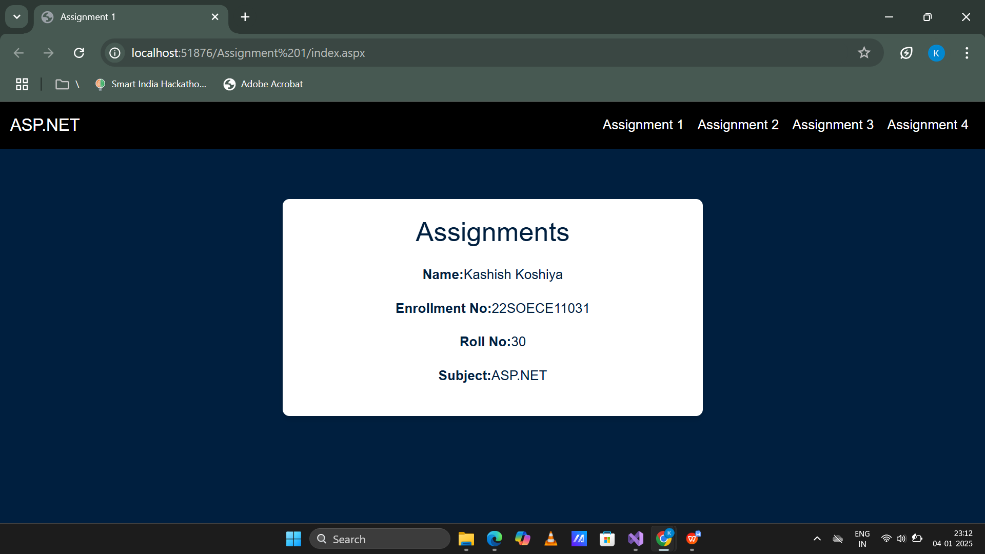

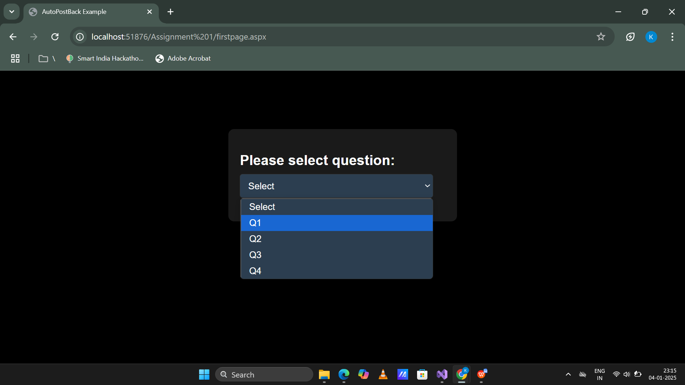

**1.Create ASP.NET page to accept a name from the user and display welcome message.**

**Display_name.aspx**

**Code**

<%@ Page Language="C#" AutoEventWireup="true" CodeBehind="display_name.aspx.cs" Inherits="WebApplication1.Assignment_1.display_name1" %>

<!DOCTYPE html>

<html xmlns="http://www.w3.org/1999/xhtml">

<head runat="server">

<title>Styled Form</title>

<style>

/* General body styling */

body {

background-color: #000; /* Black background */

color: #f5f5f5; /* Light text color */

font-family: Arial, sans-serif;

margin: 0;

padding: 0;

display: flex;

flex-direction: column;

align-items: center;

height: 100vh;

}

/* Centering and styling the form container */

#form1 {

margin-top:150px;

background-color: #1a1a1a; /* Dark gray container */

padding: 20px;

border-radius: 10px;

box-shadow: 0 4px 8px rgba(0, 0, 0, 0.5);

width: 300px;

margin-bottom: 20px;

}

/* Heading styles */

h3 {

margin: 0;

margin-bottom: 10px;

color: #ffffff; /* Bright white */

}

h5 {

margin: 0;

color: #dddddd; /* Slightly dimmer white */

}

/* Input field styling */

input[type="text"] {

width: 93%;

padding: 10px;

margin-bottom: 15px;

border: none;

border-radius: 5px;

background-color: #333; /* Dark gray */

color: #f5f5f5; /* Light text */

}

input[type="text"]::placeholder {

color: #bbb; /* Placeholder text */

}

/* Button styling */

input[type="submit"], button {

width: 100%;

background-color: #007bff; /* Light blue */

color: #fff; /* White text */

border: none;

padding: 10px 15px;

border-radius: 5px;

cursor: pointer;

}

input[type="submit"]:hover, button:hover {

background-color: #0056b3; /* Darker blue on hover */

}

/* Question box styling */

</style>

</head>

<body>

<!-- Question Box -->

<!-- Form -->

<form id="form1" runat="server">

<h5><p style="margin-bottom:5px;">Enter Your Name:</p></h5>

<asp:TextBox ID="TextBox1" runat="server" Placeholder="Enter your name"></asp:TextBox>

<asp:Button ID="Button1" runat="server" OnClick="Button1_Click" Text="Submit" /><br /><br />

<asp:Label ID="Label1" runat="server" Text="Label" Visible="False" Font-Bold="True"></asp:Label>

</form>

<!-- Navigation Buttons -->

</body>

</html>

**Display_name.aspx.cs:**

using System;

using System.Collections.Generic;

using System.Linq;

using System.Web;

using System.Web.UI;

using System.Web.UI.WebControls;

namespace WebApplication1.Assignment_1

{

public partial class display_name1 : System.Web.UI.Page

{

protected void Page_Load(object sender, EventArgs e)

{

}

protected void Button1_Click(object sender, EventArgs e)

{

string name = TextBox1.Text;

Label1.Visible=true;

Label1.Text=name;

TextBox1.Text = "";

}

}

}

**Output Screenshot:**

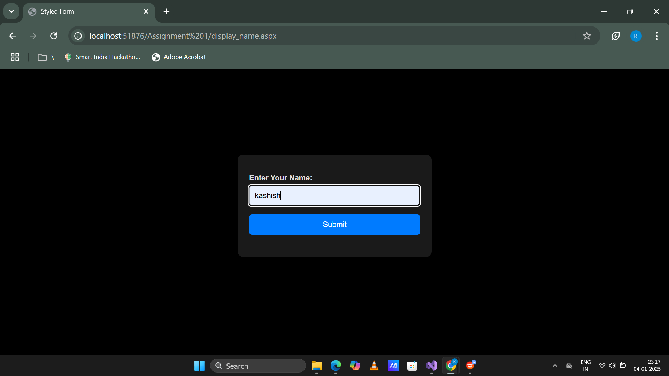

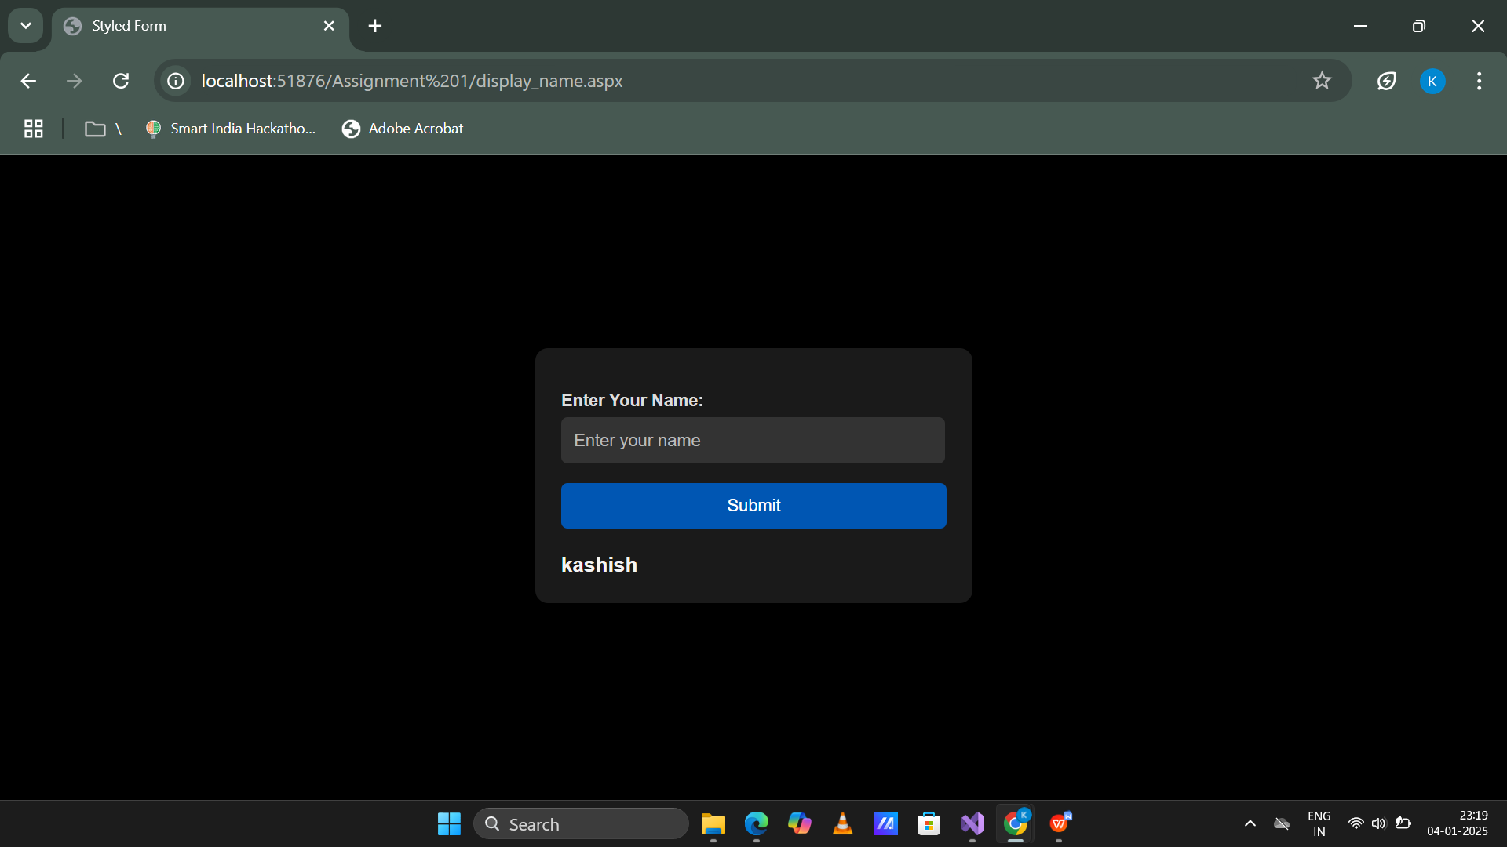

**2.Create ASP.NET page to generate the Temperature Conversion.**

**temperture_conversation.aspx Code:**

<%@ Page Language="C#" AutoEventWireup="true" CodeBehind="temperture_conversation.aspx.cs" Inherits="WebApplication1.Assignment_1.temperture_conversation" %>

<!DOCTYPE html>

<html xmlns="http://www.w3.org/1999/xhtml">

<head runat="server">

<title>Temperature Conversion</title>

<style>

/* General body styling */

body {

background-color: #121212; /* Dark black background */

color: #ffffff; /* Light text color */

font-family: 'Arial', sans-serif;

margin: 0;

padding: 0;

display: flex;

justify-content: center;

align-items: center;

height: 100vh;

}

/* Form container styling */

form {

background-color: #1e1e1e; /* Slightly lighter black for contrast */

padding: 20px;

border-radius: 10px;

box-shadow: 0 4px 8px rgba(0, 0, 0, 0.5);

width: 350px;

text-align: center;

}

/* Title styling */

form span {

font-size: 24px;

font-weight: bold;

color: #f5f5f5; /* Light gray text */

margin-bottom: 15px;

display: block;

}

/* Input field styling */

input[type="text"] {

width: calc(100% - 20px);

padding: 10px;

margin: 15px 0;

border: 1px solid #333;

border-radius: 5px;

background-color: #2e2e2e; /* Dark gray */

color: #ffffff; /* Light text */

font-size: 16px;

}

input[type="text"]::placeholder {

color: #aaaaaa; /* Placeholder color */

}

/* Radio button styling */

input[type="radio"] {

margin: 10px 5px;

accent-color: #007bff; /* Blue accent for radio buttons */

}

label {

font-size: 14px;

color: #cccccc; /* Light gray for labels */

margin-right: 10px;

}

/* Button styling */

input[type="submit"],

button {

background-color: #007bff; /* Bright blue button */

color: #ffffff; /* White text */

border: none;

padding: 10px 15px;

border-radius: 5px;

cursor: pointer;

width: 100%;

margin-top: 10px;

font-size: 16px;

}

input[type="submit"]:hover,

button:hover {

background-color: #0056b3; /* Darker blue for hover */

}

/* Label for result */

.result-label {

font-size: 16px;

font-weight: bold;

color: #ffffff; /* White text for results */

margin-top: 15px;

display: block;

}

</style>

</head>

<body>

<form id="form1" runat="server">

<span>Temperature Conversion</span>

Enter Value:

<asp:TextBox ID="TextBox1" runat="server" OnTextChanged="TextBox1_TextChanged" placeholder="Enter temperature"></asp:TextBox>

<br />

<label for="RadioButton1">

<asp:RadioButton ID="RadioButton1" runat="server" Text="Celsius to Fahrenheit" GroupName="Conversion" />

</label><br />

<label for="RadioButton2">

<asp:RadioButton ID="RadioButton2" runat="server" Text="Fahrenheit to Celsius" GroupName="Conversion" />

</label>

<br />

<asp:Button ID="Button1" runat="server" OnClick="Button1_Click" Text="Button" />

<asp:Label ID="Label1" runat="server" Text="Result will appear here" CssClass="result-label"></asp:Label>

</form>

</body>

</html>

**temperture_conversation.aspx.cs Code**

using System;

using System.Collections.Generic;

using System.Linq;

using System.Web;

using System.Web.UI;

using System.Web.UI.WebControls;

namespace WebApplication1.Assignment_1

{

public partial class temperture_conversation : System.Web.UI.Page

{

protected void Page_Load(object sender, EventArgs e)

{

}

protected void TextBox1_TextChanged(object sender, EventArgs e)

{

}

protected void Button1_Click(object sender, EventArgs e)

{

try

{

double convertedTemperature;

double inputTemperature = Convert.ToDouble(TextBox1.Text);

// Check which conversion is selected

if (RadioButton1.Checked)

{

// Celsius to Fahrenheit conversion

convertedTemperature = (inputTemperature * 9 / 5) + 32;

Label1.Text = $"Temperature in Fahrenheit: {convertedTemperature:F2}°F";

}

else if (RadioButton2.Checked)

{

// Fahrenheit to Celsius conversion

convertedTemperature = (inputTemperature - 32) * 5 / 9;

Label1.Text = $"Temperature in Celsius: {convertedTemperature:F2}°C";

}

else

{

// No conversion option selected

Label1.Text = "Please select a conversion type.";

}

}

catch (FormatException)

{

// Handle invalid input

Label1.Text = "Please enter a valid numerical temperature.";

}

catch (Exception ex)

{

// Handle any other errors

Label1.Text = $"An error occurred: {ex.Message}";

}

}

}

}

**Output Screenshot:**

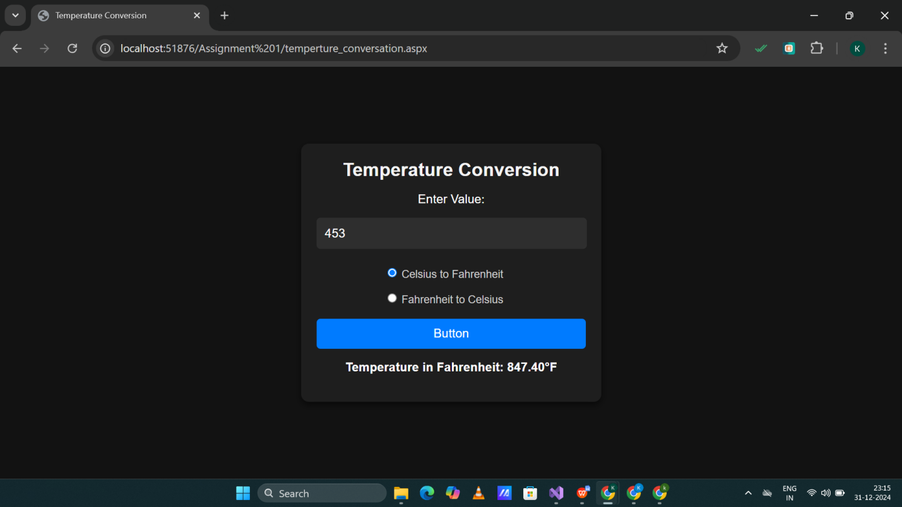

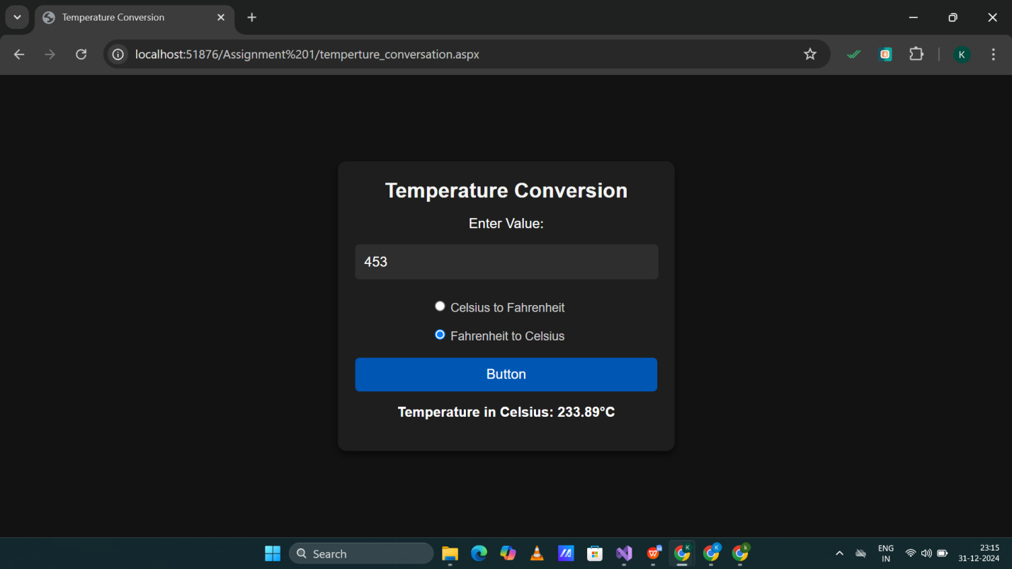

**3.Create a component that receives two numbers from the user through a Web Form, and based on the user’s selection it performs algebraic operations on the two numbers and returns the result to the Web Form. The result should be displayed in the Web Form.**

**Add_num.aspx.cs Code:**

using System;

using System.Collections.Generic;

using System.Linq;

using System.Web;

using System.Web.UI;

using System.Web.UI.WebControls;

namespace WebApplication1.Assignment_1

{

public partial class add_num : System.Web.UI.Page

{

protected void Page_Load(object sender, EventArgs e)

{

}

protected void Button1_Click(object sender, EventArgs e)

{

try

{

int a = Convert.ToInt32(TextBox1.Text);

int b = Convert.ToInt32(TextBox2.Text);

int c;

string operation = DropDownList1.SelectedValue;

switch (operation)

{

case "Add":

c = a + b;

break;

case "Substraction":

c = a - b;

break;

case "Multiply":

c = a * b;

break;

case "Divide":

if (b == 0)

{

Label1.Text = "Can not divisible by zero";

Label1.Visible = true;

return;

}

c = a / b;

break;

default:

Label1.Text = "Invalid Operation";

Label1.Visible = true;

return;

}

Label1.Text = $"Result : {c}";

Label1.Visible = true;

Label1.ForeColor = System.Drawing.Color.Green;

}

catch (FormatException)

{

// Handle invalid input

Label1.Text = "Please enter valid numbers.";

Label1.ForeColor = System.Drawing.Color.Red;

Label1.Visible = true;

}

}

}

}

**add_num.aspx Code**

<%@ Page Language="C#" AutoEventWireup="true" CodeBehind="add_num.aspx.cs" Inherits="WebApplication1.Assignment_1.add_num" %>

<!DOCTYPE html>

<html xmlns="http://www.w3.org/1999/xhtml">

<head runat="server">

<title>Addition Calculator</title>

<style>

/* Body styling */

body {

background-color: #000000; /* Pure black background */

color: #ffffff; /* White text */

font-family: Arial, sans-serif;

display: flex;

justify-content: center;

align-items: center;

height: 100vh;

margin: 0;

}

/* Form container */

form {

background-color: #1a1a1a; /* Dark gray container */

padding: 30px;

border-radius: 10px;

box-shadow: 0 4px 8px rgba(0, 0, 0, 0.7);

width: 300px;

}

/* Title styling */

h2 {

color: #ffffff; /* White color for the title */

text-align: center;

margin-bottom: 20px;

}

/* Label styling */

label {

display: block;

margin-bottom: 5px;

font-size: 16px;

text-align: left;

}

/* Input field styling */

input[type="text"] {

width: calc(100% - 20px);

padding: 10px;

margin-bottom: 15px;

border: 1px solid #333;

border-radius: 5px;

background-color: #2e2e2e; /* Dark gray */

color: #ffffff; /* White text */

font-size: 16px;

}

input[type="text"]::placeholder {

color: #aaaaaa; /* Light gray placeholder */

}

/* Dropdown styling */

select{

width: 100%;

padding: 10px;

margin-bottom: 15px;

border: 1px solid #333;

border-radius: 5px;

background-color: #2e2e2e; /* Dark gray */

color: #ffffff; /* White text */

font-size: 16px;

}

/* Button styling */

input[type="submit"]

{

background-color: #007bff; /* Bright blue */

color: #ffffff; /* White text */

border: none;

padding: 10px 15px;

border-radius: 5px;

cursor: pointer;

font-size: 16px;

width: 100%;

text-align: center;

}

input[type="submit"]:hover

{

background-color: #0056b3; /* Darker blue */

}

/* Label styling for result */

asp:Label {

margin-top: 15px;

display: block;

font-size: 16px;

font-weight: bold;

color: #00ff00; /* Bright green for result */

}

</style>

</head>

<body>

<form id="form1" runat="server">

<h2>Addition Calculator</h2>

<label for="TextBox1">Enter Num 1:</label>

<asp:TextBox ID="TextBox1" runat="server" placeholder="Enter first number"></asp:TextBox>

<label for="TextBox2">Enter Num 2:</label>

<asp:TextBox ID="TextBox2" runat="server" placeholder="Enter second number"></asp:TextBox>

<label for="DropDownList1">Select Operation:</label>

<asp:DropDownList ID="DropDownList1" runat="server">

<asp:ListItem Text="Addition" Value="Add"></asp:ListItem>

<asp:ListItem Text="Subtraction" Value="Subtract"></asp:ListItem>

<asp:ListItem Text="Multiplication" Value="Multiply"></asp:ListItem>

<asp:ListItem Text="Division" Value="Divide"></asp:ListItem>

</asp:DropDownList><br /><br />

<asp:Button ID="Button1" runat="server" OnClick="Button1_Click" Text="Calculate" />

<br /><br />

<asp:Label ID="Label1" runat="server" Text="Result will appear here" Visible="False"></asp:Label>

</form>

</body>

</html>

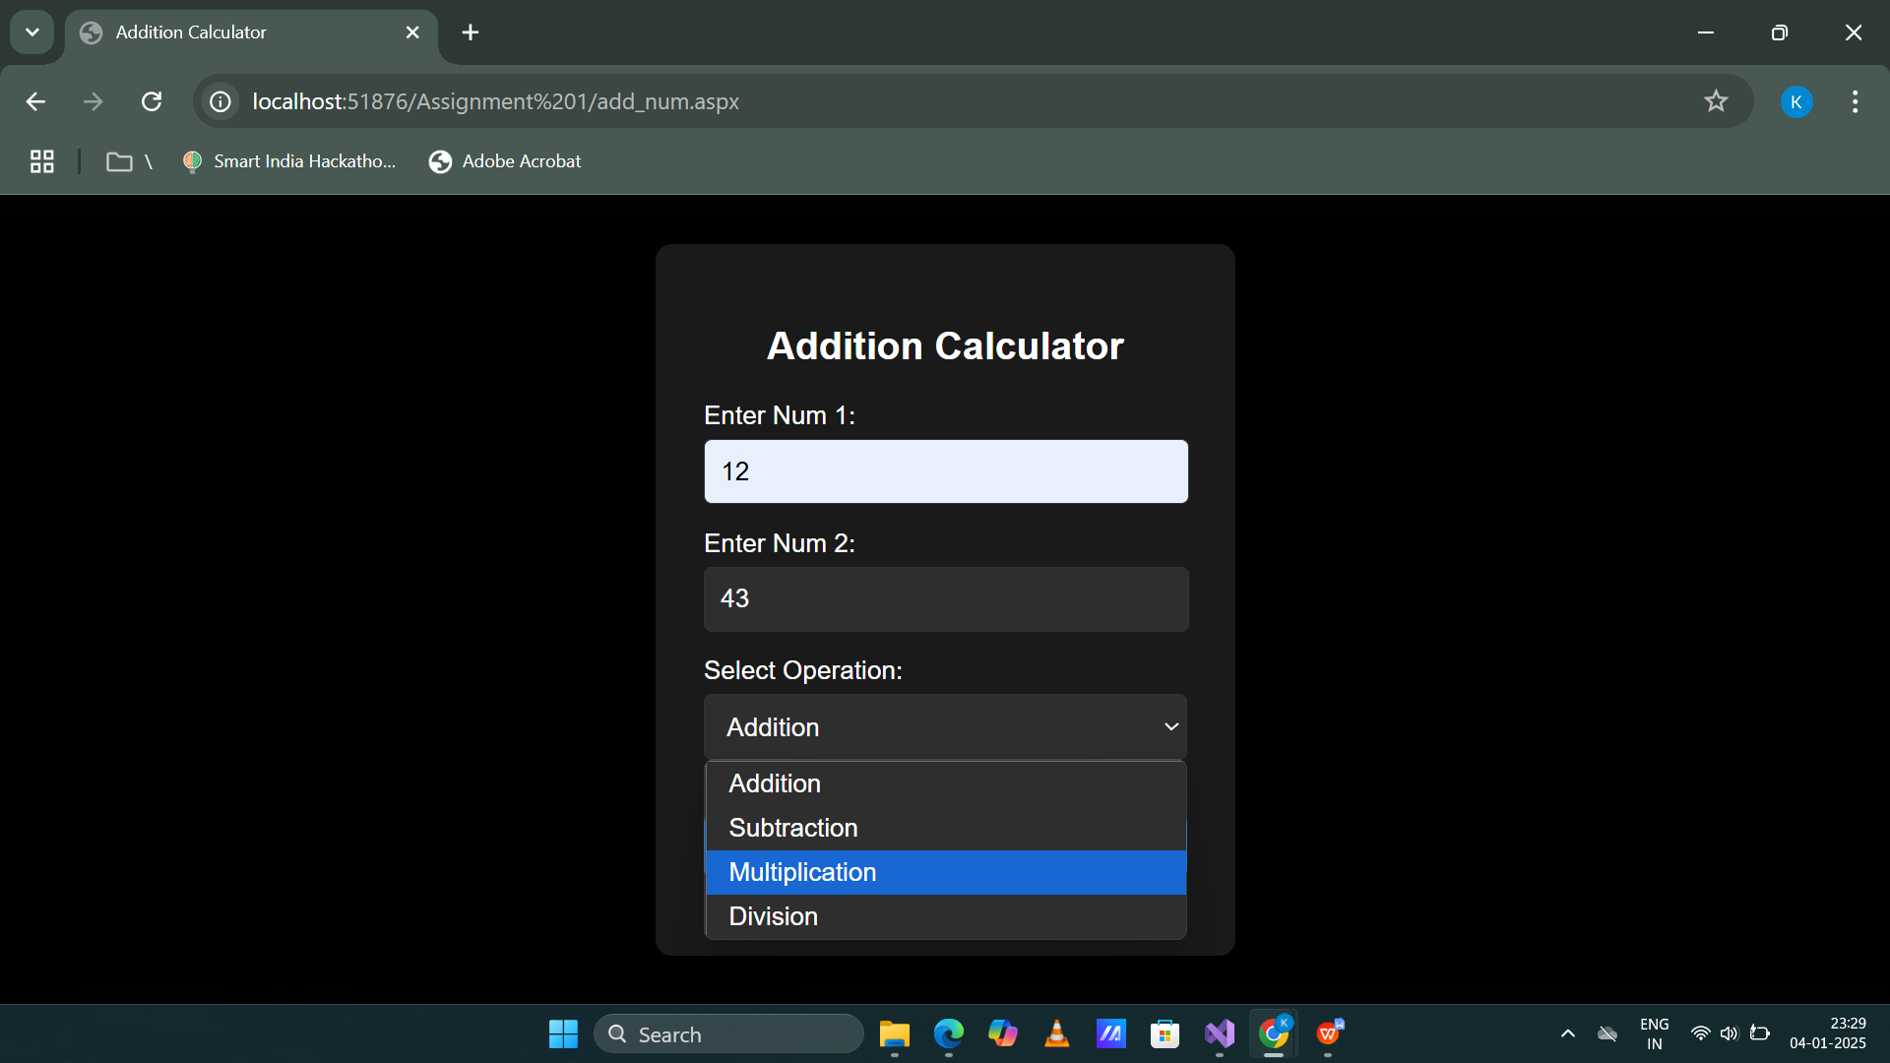

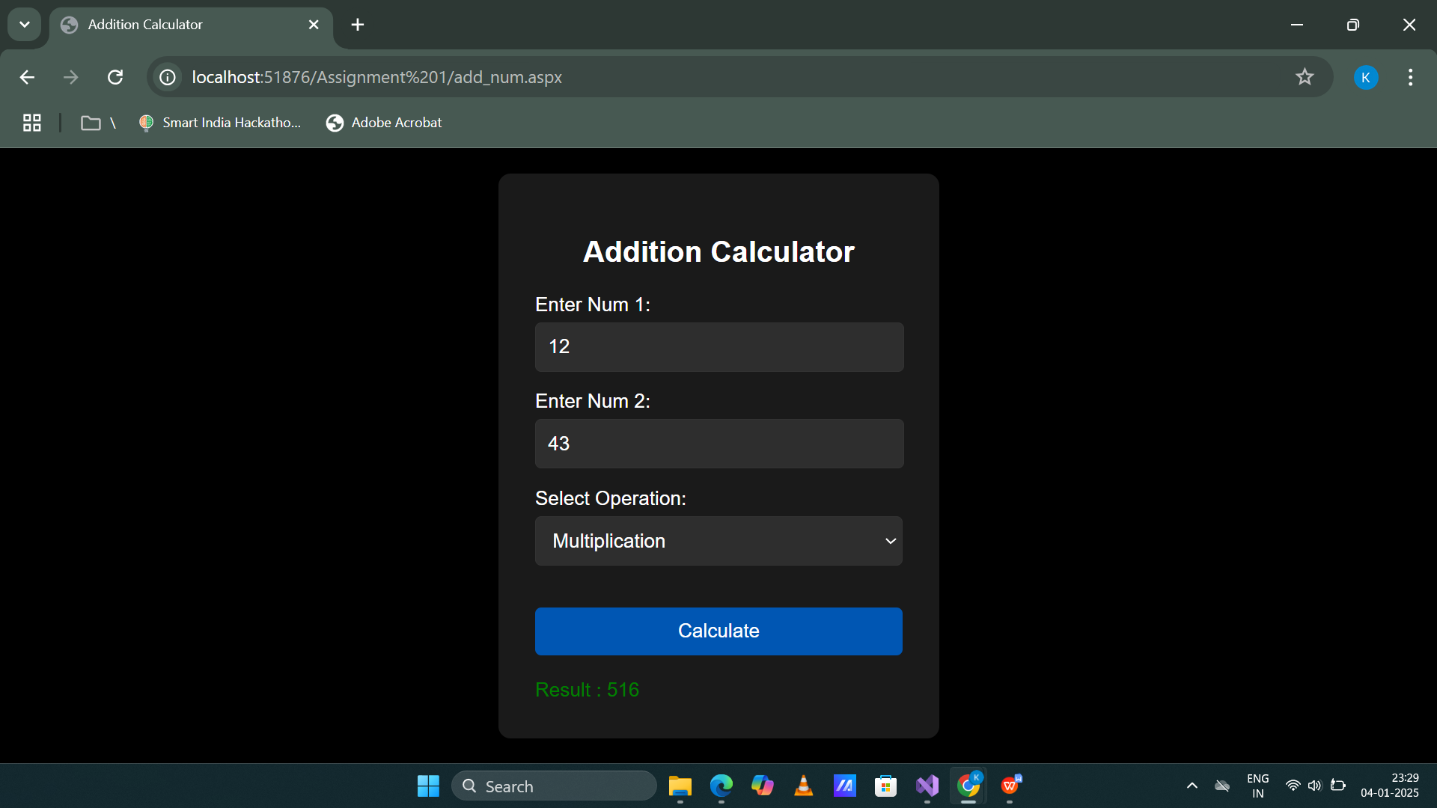

1. **Create ASP.NET page to demonstrate “AutoPostBack” property for controls available.**

**autopostback.aspx.cs:**

using System;

using System.Collections.Generic;

using System.Linq;

using System.Web;

using System.Web.UI;

using System.Web.UI.WebControls;

namespace WebApplication1.Assignment_1

{

public partial class autopostback : System.Web.UI.Page

{

protected void Page_Load(object sender, EventArgs e)

{

}

protected void DropDownList1_SelectedIndexChanged(object sender, EventArgs e)

{

Label2.Text = "You selected: " + DropDownList1.SelectedItem.Text;

}

protected void TextBox1_TextChanged(object sender, EventArgs e)

{

Label2.Text = "You entered: " + TextBox1.Text;

}

}

}  
  
autopostback.aspx:

<%@ Page Language="C#" AutoEventWireup="true" CodeBehind="autopostback.aspx.cs" Inherits="WebApplication1.Assignment_1.autopostback" %>

<!DOCTYPE html>

<html xmlns="http://www.w3.org/1999/xhtml">

<head runat="server">

<title>AutoPostBack Example</title>

<style>

body {

background-color: black; /* Dark background */

font-family: Arial, sans-serif;

color: #ffffff;

margin: 0;

padding: 0;

}

.container {

width: 30%;

margin: 100px auto 50px; /* Adjust the margin-top value here */

background-color: #1a1a1a;

border-radius: 10px;

box-shadow: 0 4px 8px rgba(0, 0, 0, 0.5);

padding: 20px;

}

.container h3 {

color: white; /* Blue heading text */

margin-bottom: 10px;

}

.container label {

display: block;

margin-bottom: 5px;

font-size: 14px;

color: #ffffff;

}

.container select,

.container input[type="text"] {

width: 94%;

padding: 10px;

margin-bottom: 20px;

border: 1px solid #333;

border-radius: 5px;

background-color: #2c3e50; /* Input background */

color: #ffffff;

font-size: 16px;

}

.container .result {

padding: 10px;

color: #ffffff;

text-align: center;

font-size: 16px;

}

</style>

</head>

<body>

<form id="form1" runat="server">

<div class="container">

<h3>Select an Option:</h3>

<asp:DropDownList ID="DropDownList1" runat="server" AutoPostBack="True" OnSelectedIndexChanged="DropDownList1_SelectedIndexChanged">

<asp:ListItem Text="Insert" Value="1"></asp:ListItem>

<asp:ListItem Text="Kashish" Value="2"></asp:ListItem>

<asp:ListItem Text="Koshiya" Value="3"></asp:ListItem>

</asp:DropDownList>

<h3>Enter Text:</h3>

<asp:TextBox ID="TextBox1" runat="server" AutoPostBack="True" OnTextChanged="TextBox1_TextChanged"></asp:TextBox>

<h3>Result:</h3>

<asp:Label ID="Label2" runat="server" CssClass="result" Text=""></asp:Label>

</div>

</form>

</body>

</html>

